**POLYASPARTIC FLAKE SYSTEM**

Polyaspartic Flake System is a quick-turnaround, mosaic-patterned floor covering. Decorative vinyl chips and high-gloss polyaspartic resin are applied in a single broadcast, resulting in a nominal 1/16" thick surface. The coating's innovative base chemistry enables fast-cure installation and provides tough chemical-resistant protection.

**BENEFITS**

* Aesthetically pleasing appearance
* Limitless color options
* Seamless and sanitary
* Chemical and stain resistant
* High-gloss finish
* Contributes to LEED v4 credits

**USES**

* Nursing homes and healthcare facilities
* Clean rooms and pharmaceutical facilities
* Garage and shop floors
* Locker rooms and restrooms
* Schools and cafeterias

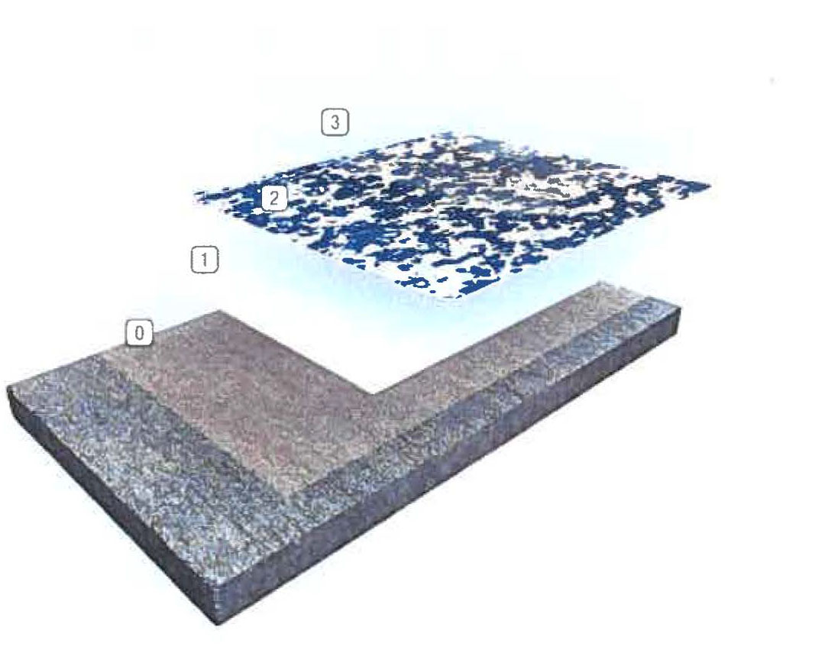

|  |  |  |  |
| --- | --- | --- | --- |
| 0 | **Primer** | 2 | **Broadcast** |
|  |  |  |  |
| 1 | **Base Coat** | 3 | **Grout I Seal Coat** |

**TYPICAL PHYSICAL PROPERTIES**

|  |  |
| --- | --- |
| **Color** | Custom color blends available |
| **Abrasion Resistance**  ASTM D4060. CS-17 Wheel,  1.000 cycles | 80 mg/loss |
| **Adhesion to Concrete**  ASTM D4541 | 425 psi  (concrete failed) |
| Flammability | Self-extinguishing over concrete |
| **Impact Resistance**  MIL-D-3134J | Direct. 100 inch-pounds |
| **Resistance to Elevated**  Temperatures  ASTM D2794 | No slip or flow at required  temperature of 158'F |
| ASTM D = Resin only |  |