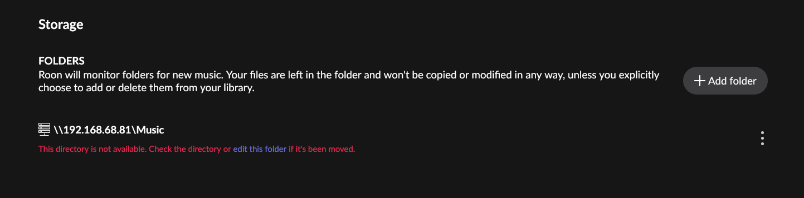
After Remove
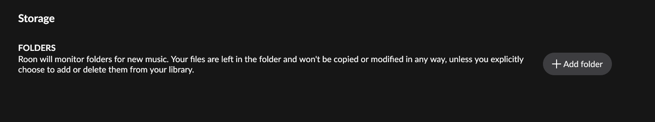
After Add new: The Removed folder is still there
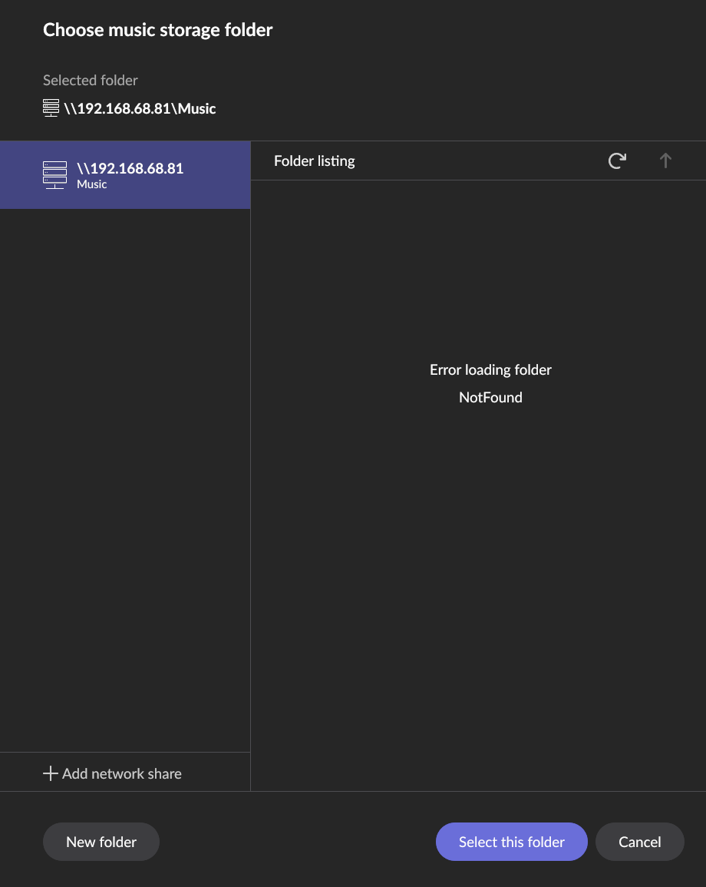

Try to add network share with new User ID and PW
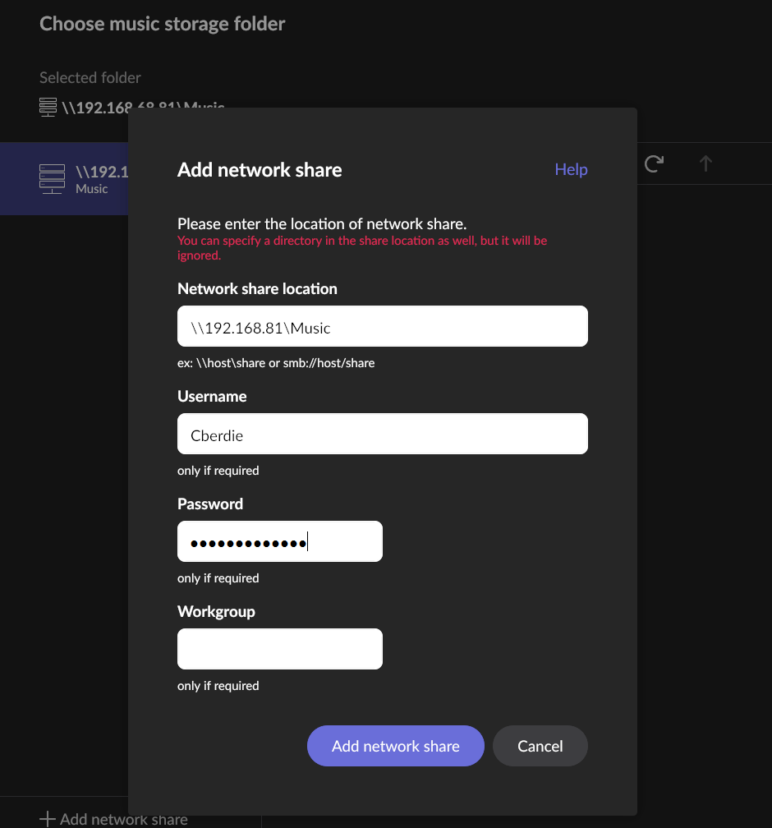
Unexpected Error trying to (re)add network share
