1. **Roon Core:**

Innuos Zen Mk.II

InnuOS 2.6.4

Roon Version: 2.0

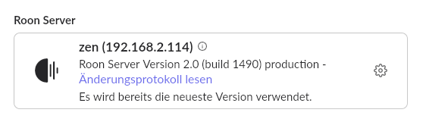

1. **Apple Ipad** -> no issues with access to roon core

Apple iPad (9.7), 5. Generation

iPadOS 16.7.10

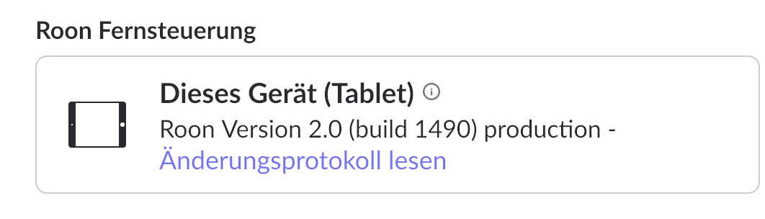

1. **MacBook Pro M1** -> no issues with access to roon core

macOS Ventura 13.7.1

1. **Apple Ipad new -> no connection to roon core**

iPad Air (11”, M2)

iPadOS 18.2.1

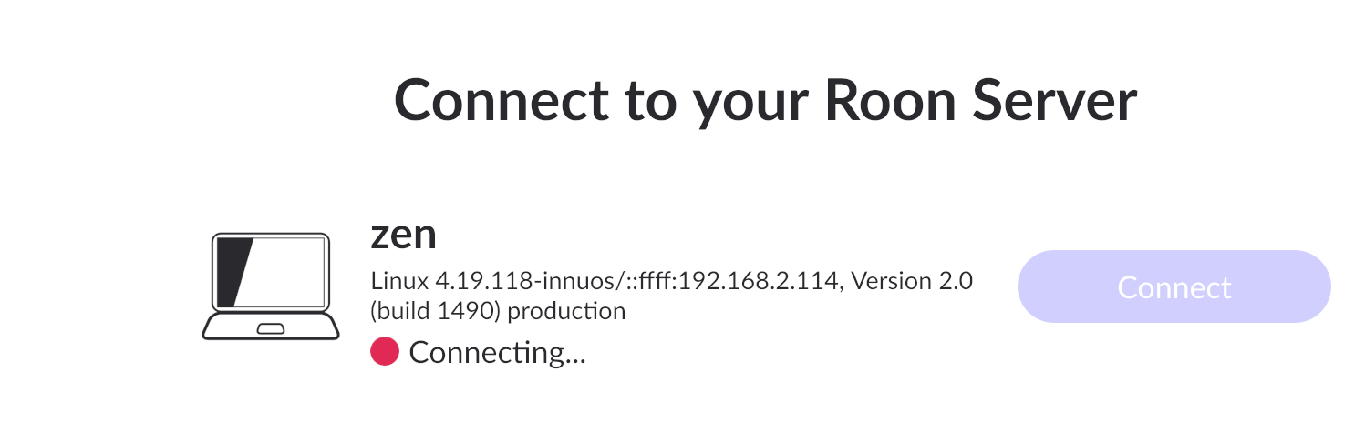

What I’ve tried so far:

1. Restart entire system (roon core, Macbook Pro, both iPads, Router etc.)
2. Remove roon app from iPad air and install again