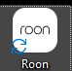

Application not opening after update. Problem has been explained in detail earlier in the thread. Please see screenshot.

